**Asknknow – a questioning and answering website**

**Course: SE505 Software Project Lab – II**

**Submitted by**

|  |  |  |
| --- | --- | --- |
| ***Samima Aktar***  ***Uddip Acharjee Shuvo*** | ***Roll: 0841***  ***Roll:0844*** | ***2014-2015***  ***2014-2015*** |

**Document Version 1.0**

**Submitted to**

**SPL II Committee**



**Institute of Information Technology**

**University of Dhaka**

**[20-03-2018]**

LETTER OF TRANSMITTAL

20th March, 2018

Md. Nurul Ahad Tawhid

Assistant Professor,

Institute of Information Technology,

University of Dhaka

Subject: Submission of Software Requirement Specification report of Software Project Lab-II

Sir,

With due respect, we  are very glad to submit our Software Requirement Specification report of our project **Asknknow** – a questioning and answering website. Although this report may have many drawbacks, we have given our highest effort to fulfill all the requirements of our stakeholders and to prepare a detailed documentation that will help us in future.

Therefore, we hope that you will be kind enough to overlook our mistakes and acknowledge the our attempt that we have put in this document.

Sincerely,

Samima Aktar (0841)

Uddip Acharjee Shuvo (0844)

Institute of Information Technology,

University of Dhaka

Signature of Supervisor

**ACKNOWLEDGEMENT**

First of all I would like to thank the Almighty for enabling us to complete this project.

Then we would like to express our heartiest gratitude to all of those who helped us to accomplish the tiresome work of identifying the requirements for the project titled ‘asknknow’. We would like to specially thank to Md. Nurul Ahad Touhid, our supervisor for helping us to gather requirement as well as keeping ourselves connected with the project stakeholders.

Finally, we are grateful to the Institute of Information Technology for giving us the opportunity to do a project of great caliber.

ABSTRACT

This document contains the software requirements and specifications for Software Project Lab-2. It contains a detailed depiction of the requirements of our project ‘Asknknow’. It includes a scenario-based model, data-based model, class-based model and behavioral model. Using this document as a guide, we are describing the requirements, necessary diagrams, procedures, designs for database and working sequence of our project.

This document will help to make the software according to the demand of the stakeholders.

Table of Contents

CHAPTER 1: Introduction of SRS 1

1.1 Purpose 1

1.2 Intended Audience 1

1.3 Conclusion 1

CHAPTER 2: INCEPTION 2

2.1 Introduction 2

2.2 Establishing the groundwork 2

2.3 List of Stakeholders 2

2.3 Recognizing Multiple Viewpoints 3

2.4 Working Towards Collaboration 3

2.5 Requirement Questionnaire 4

2.6 Conclusion 4

CHAPTER 3: ELICITATION 5

3.1 Introduction 5

3.2 Eliciting Requirements 5

3.2.1 Collaborative Requirements Gathering: 5

3.2.2 Quality Function Deployment: 6

3.3 Usage Scenario 7

CHAPTER 4 : SCENARIO-BASED MODELLING 10

4.1 DEFINITION OF USE CASE 10

4.2 ACTORS 10

4.3 USE CASE DIAGRAMS 11

4.3.1 Level-0 Use Case Diagram-ANK 11

4.3.2 Level-1 Use Case Diagram-Subsystems 12

4.3.3 LEVEL- 1.1 Use Case Diagram-Authentication 13

4.3.4 LEVEL- 1.1.1 CREATING ACCOUNT 14

4.3.5 LEVEL 1.1.2 USE CASE DIAGRAM-ACCESSING ACCOUNT 15

4.3.6 LEVEL-1.2 USE CASE DIAGRAM-ACTIVITY MANAGEMENT 16

4.3.7 LEVEL-1.3 USE CASE DIAGRAM-QUESTION MANAGEMENT 17

4.3.8 LEVEL-1.4 USE CASE DIAGRAM-USER MANAGEMENT 18

4.4 ACTIVITY DIAGRAM OF ANK 19

4.5 SWIMLANE DIAGRAM OF ANK 25

CHAPTER 5: DATA-BASED MODELLING 31

5.1 Grammatical Parsing and Analysis 31

5.2 Potential Data Objects 32

5.3 Analysis of Potential Data Objects 33

5.4 Final Data Objects 33

5.5 Data Object Relationship 34

5.6 Entity Relation Diagram 34

5.7 Schema Tables 35

CHAPTER 6: CLASS BASED MODELLING 37

6.1 Grammatical Parsing and Analysis 37

6.1.1 Class Identification with General Classification 37

6.1.2. Class Identified With Selection Criteria 39

6.2 Preliminary Classes 40

6.3 Verb Identification 40

6.4 Attributes and Methods of Preliminary Classes 42

6.5 Analysis of Potential Classes 43

6.6 Final Classes 43

6.7 Attributes, Methods of Final Classes 43

6.7 Responsibilities and Collaborative Classes of Final Classes 44

6.8 Class Diagram 45

**CHAPTER 7: FLOW-ORIENTED MODELING** 47

**7.1 Data flow diagram** 47

**7.1.1 Level 0 Data Flow Diagram** 47

**7.1.2 Level 1 Data Flow Diagram** 47

**7.1.3 Level 2 Data Flow Diagram** 48

CHAPTER 8: BEHAVIORAL MODELING 49

8.1 Event Identification 49

8.2 State Transition 50

8.3 Sequence diagram 53

# CHAPTER 1: Introduction of SRS

## 1.1 Purpose

This chapter aims to specify the purposes of this document and its intended audiences. This document is the Software Requirement Specification (SRS) for “Asknknow”- a questioning and answering website. It focuses on elaborately defining the functional and nonfunctional requirements of the system as well as provides an outline of the core design of the complete system. Specifically, this document is written to:

* Build a common reference point for all stakeholders, including but not limited to customers, developers, testers to reduce communication overhead.
* Provide an unambiguous and consistent high level overview of core design of the system for developers to implement.
* Serve as a basis for preparing a general schedule and future modifications in the system.

## 1.2 Intended Audience

This SRS is intended for several audiences including customers, designers, developers and testers.

* The customers will use this document to ensure their functional requirements has properly been met in the end product.
* The project manager will use this document to plan a schedule and estimate cost and delivery date.
* The designer will use the high level architecture outlined in this document to design the complete system to meet the customer requirements, which is also detailed in this document.
* The developers will periodically refer back to this document to ensure their implementation corresponds to the customer requirements.
* The testers will use this document to get a clear picture of functionality of individual components and whole system to test against.

## 1.3 Conclusion

This analysis of the audience helped us to focus on the users who will be using our system. This overall document will help each and every person related to this project to have a better idea about the project..

# CHAPTER 2: INCEPTION

In this chapter, the inception part of the software requirement analysis of our project will be discussed briefly.

To establish the groundwork we have worked with the following factors related to the inception phases:

* List of stakeholders.
* Recognizing multiple viewpoints.
* Working towards collaboration.

## 2.1 Introduction

Inception is the beginning phase of requirements engineering. It defines how does a software project get started and what is the scope and nature of the problem to be solved. The goal of the inception phase is to identify concurrence needs and conflict requirements among the stakeholders of a software project. At project inception, we establish a basic understanding of the problem, the people who want a solution, the nature of the solution that is desired, and the effectiveness of preliminary communication and collaborations between the other stakeholders and the software team.

## 2.2 Establishing the groundwork

To establish the groundwork we have worked with the following factors related to the inception phases:

* Identifying all stakeholders.
* Recognizing multiple viewpoints
* Working towards collaboration.
* Asking requirement questions.

## 2.3 List of Stakeholders

Stakeholder refers to any person or group who will be affected by the system directly or indirectly. Stakeholders include end-users who interact with the system and everyone else in an organization that may be affected by its installation. At inception, a list of people who will contribute input as requirements are elicited. The initial list will grow as stakeholders are contacted because every stakeholder will be asked: “Whom else do you think I should talk to?” We defined stakeholders as anybody or organization directly or indirectly associated with the end software. We identified following entities as our system’s stakeholder:

* Registered users
* General users
* Website administrator
* Project Manager, Developer and tester

## 2.3 Recognizing Multiple Viewpoints

As many different stakeholders exist, the requirements of the system are explored from many different points of view.

**User’s viewpoint**

* The system should have easy and user friendly way for accessing all the questions
* The questions should be categorized for finding them quickly
* Every registered user should be able to see their activities such as asked question list, answered question list.
* There should be voting system for every answers of a question so that it becomes easier to evaluate or assess the standard of the answer
* It should provide with the facility to sort out the experts of a specific subject.
* General user can see the questions and answers without registration.

**Website Admin’s viewpoint**

* There should be easy and simple arrangement for administration activities.
* The system must provide with the notification system for the experts so that they can get notification when a question is asked of their domain area
* It must include with high security and strong authentication.

**Developer’s viewpoint**

* Total development time should not exceed two months
* Top security and highly efficient features should not be expected

## 2.4 Working Towards Collaboration

Every stakeholders has their own requirements from their own point of view. We followed following steps to merge all the requirements. We-

* Identified the common and conflicting requirements
* Categorized the requirements
* Take priority points for each requirements from stakeholders
* Make final decision about the requirements

Our first step was to find the common grounds among multiple viewpoints. We singled out the conflicting ones to finalize our overall requirements.

Common requirements

* User friendly
* Efficient system
* Error free
* Strong authentication

Conflicting requirements

* Website administrator expects a highly secure system while for the development team it is not possible to provide complete security.
* Too many requirements to be fulfilled within a short time. So some requirements cannot be fulfilled such as secure communication, and highly efficient modules

Final requirements

* Notification to the experts of an asked question should be automated
* Voting system for each answer should be provided
* Categorized list of question should be given
* Admin can add new user and remove existing user

## 2.5 Requirement Questionnaire

Our questions were initially context free, which focused on the user and other stakeholders, the overall project goals and benefits. This created a basic understanding of the problem for us. After having a general concept of the system, we got into details. Our second set of questions were intended to provide us a deeper understanding of the problem and solution. And lastly, we judged the effectiveness of our communication through a set of meta questions.

## 2.6 Conclusion

The Inception phase helped us to establish basic understanding about the “Asknknow” (ANK) identify the stakeholders who will be benefited if this system becomes automated, define the nature of the system and the tasks done by the system, and establish a preliminary communication with our stakeholders.

In our project, we have established a basic understanding of the problem, the nature of the solution that is desired and the effectiveness of preliminary communication and collaboration between the stakeholders and the software team. More studies and communication will help both sides (developer and client) to understand the future prospect of the project. Our team believes that the full functioning document will help us to define that future prospect.

# CHAPTER 3: ELICITATION

## 3.1 Introduction

Requirements elicitation is also called requirements gathering. The purpose of this step is to combine elements of problem solving, elaboration, negotiation and specification. In requirements engineering requirements elicitation is the practice of collecting the requirements of a system from users, customers and other stakeholders. We have faced many problems like understanding the problems, problems of making questions for the stakeholders, problems of less communication with the stakeholders for time limitation, problems of volatility. Though it is not too easy to gather requirements within a very short time, we have surpassed these problems in an organized and systematic manner.

## 3.2 Eliciting Requirements

In requirements engineering, requirements elicitation is the practice of collecting the requirements of a system from users, customers and other stakeholders. It specifies the answer to the questions like what the objectives for the system or product are, what is to be accomplished, how the system or product fits into the needs of the business, and finally, how the system is to be used on a day-to-day basis. We have seen Question and Answer (Q&A) approach in the previous chapter where the inception phase of requirement engineering has been described. The main task of this phase is to combine the elements of problem solving, elaboration, negotiation and specification. We have finished the following tasks for eliciting requirements-

* Collaborative Requirements Gathering
* Quality Function Deployment
* Usage Scenarios
* Elicitation work products

### 3.2.1 Collaborative Requirements Gathering:

We have met with many stakeholders in the Inception phase such as the students and teacher of different institution of various department. They were questioned about their requirements, expectations and expected structure of the program. These meetings created an indecisive state for us to elicit the requirements. To solve this problem we have met with the stakeholders (who are acting a vital rule in the whole process) again to elicit the requirements. We discussed to define the scopes and extents to which we could develop the system. A slightly different scenario from these approaches has been found.

### 3.2.2 Quality Function Deployment:

Quality Function Deployment (QFD) is a technique that translates the needs of the customer into technical requirements for software. Ultimately the goal of QFD is to translate subjective quality criteria into objective ones that can be quantified and measured and which can then be used to design and manufacture the product. It is a methodology that concentrates on maximizing customer satisfaction from the software engineering process. So we have followed this methodology to identify the requirements for the project. The requirements, which are given below, are identified successfully by the QFD.

**Normal Requirements:**

Normal Requirements are the objectives and goals that are stated for system during meetings with the customer. Normal requirements of ANK are:

1. Signup and login system of users
2. Asking or post question section in text or image
3. Comment or reply section only for the registered users.
4. Up vote and down vote system by the viewers for a specific question and the related answer of the users.
5. View count system for a particular question
6. Question list sorted based on time of posting, most voted, unanswered etc.
7. Question tag for specifying questions of particular domain
8. Searching section for question

**Expected Requirements:**

1. Providing personal account for user
2. Secured authentication system
3. System admin should be able to approve new user or delete users

**Exciting Requirements:**

Exciting Requirements are those features that go beyond the customer’s expectations and prove to be very satisfying when present. Exciting requirements of ANK are:

1. Ranking system of the users

## 3.3 Usage Scenario

“Asknknow” -a questioning and answering website serves the following purposes:

1. Authentication:
2. Activity management:
3. Question management
4. User management
5. Notification

**Authentication:**

ANK has three types of users.

1. Admin
2. Registered user
3. General user

Any person can use this website as a general user. Then no authentication will be needed. But this time user will be restricted to access only specific area. To be a registered user one has to give the following input.

* user name
* Full name
* Designation
* email
* password

These data will be stored in database. Every time users access into the website for log in they have to provide the following data.

* User name
* password

These data will be verified every time the registered user log in. For user name, only alphanumeric characters and underscore (‘_’) are allowed. If a user tries to create an account with empty field or contain invalid input, the system shows an error message and allows him/her to try again.

To be an admin, approving from another admin is required.

**Activity management:**

This module is divided into three subsystem. They are as follows:

1. Search
2. Sort
3. Approve or delete

Under the “search” module searching are performed by different attributes. A user can search for questions, user and category.

“Sort” subsystem provides with the necessary functionalities to sort the questions according to most voted, highest answered, unanswered, date. Thus it ensures the quick and easy access to the expected query.

“Approve/delete” subsystem is reserved only for the administration purposes to accept or reject request for submitting questions and new admin.

**Question management:**

“Question management” is further divided into five more subsystems. They are as follows:

1. Question List
2. Category List
3. Ask
4. Answer
5. Upvote / Downvote

In the “Question List” subsystem, all the questions will be preserved and maintained. All the users can access the questions repository.

There will be predefined or user-defined category or “Tag” for any question in the “Category List”. Any user can access the category List. Registered user can make new Tag/s while submitting any question that belongs to completely new one. Tag/s refers to the keyword/s of that content. A question may have multiple tags. User can also edit tag/s. Registered and non-registered users can search question by using tag/s.

“Ask” subsystem will provide with the functionalities to ask a question only for the registered user. When a general user intends to ask a question, then s/he will be prompted with the opportunity for becoming a registered user by displaying the sign-up page. To ask a question a user have to provide with the following information.

* Title of the question
* Category of the question
* Question Description
* Designation of the questionnaire
* Designation of the target audience

After giving all the information, user will submit it to publish in the question repository. Then an approval from the admin panel is required. If the question is eligible for publishing, it will be published otherwise a notification massage will be sent to the user.

“Answer” subsystem will provide with the functionalities to answer any question from the question list. Only the registered user can answer any question.

“Upvote/Downvote” subsystem will allow the users to appreciate or discourage the answer by casting vote. If s/he likes the answer given by other user, s/he can upvote the answer and vice versa. Only the registered users are accessible for this subsystem. Ranking system of the users will be provided based on upvote, downvote and contribution.

**User management:**

“User management” is the subsystem for the maintenance of all the user related data. It is divided into further subsystems as follows:

* User profile
* User activity history
* User specialized domain

All the data of the user account will be maintained under this “User profile” module. A registered user can access, modify and manipulate these data.

“User activity history” will store all the activities of any specific registered user account. A registered user can ask and answer. This module will maintain the list of all the asked questions, answered questions, and the most answered category of the registered user.

“User specialized domain” will save all the domain or area of which a registered user prefers to answers. S/he may have a good command over those area. So, when any other user ask a query of those domain, s/he will be notified about this question.

**Notification:**

In the “ANK” system there will be three types of notification. They are as follows:

When a new user account is created by a general user to be registered as an admin, a notification is sent to the existing admin panel for approval or rejection him/her as a new admin.

When a registered user ask a question submitting it to publish, a notification is sent to the admin to consider the question whether it is eligible to publish.

When a registered user submit a question of a specific domain, notification will be sent to all the other registered users who are expert at that domain.

# CHAPTER 4 : SCENARIO-BASED MODELLING

## 4.1 DEFINITION OF USE CASE

A Use Case captures a contract that describes the system behavior under various conditions as the system responds to a request from one of its stakeholders. In essence, a Use Case tells a stylized story about how an end user interacts with the system under a specific set of circumstances. A Use Case diagram simply describes a story using corresponding actors who perform important roles in the story and makes the story understandable for the users.

## 4.2 ACTORS

The first step in writing a Use Case is to define that set of “actors” that will be involved in the story. Actors (such as admin, operator) are the different people that use the system or product within the context of the function and behavior that is to be described. Actors represent the roles that people play as the system operators. Every user has one or more goals when using the system

**Primary Actor**

Primary actors interact directly to achieve required system function and derive the intended benefit from the system. They work directly and frequently with the software.

**Secondary Actor**

Secondary actors support the system so that primary actors can do their work. They either produce or consume information

## 4.3 USE CASE DIAGRAMS

Use Case diagrams give the non-technical view of overall system.

### 4.3.1 Level-0 Use Case Diagram-ANK

C:\Users\UDDIP\Dropbox\5th sem\spl2\usecase new\level-0.png

Figure: Level 0 Use Case diagram-ANK

**Description of Use Case Diagram Level 0:**

After analyzing the user story we found three actors who will directly use the system as a system operator. Primary actors are those who will play action and get a reply from the system whereas secondary actors only produce or consume information. Here registered user, admin are primary actors and general user is secondary actor.

### 4.3.2 Level-1 Use Case Diagram-Subsystems

C:\Users\UDDIP\Dropbox\5th sem\spl2\usecase new\level-1.png

Figure 2: Level 1 Use Case diagram-Subsystems

**Description of Use Case Diagram Level 1:**

There are five subsystems in the “Asknknow” (ANK). They are:

1. Authentication
2. Activity management
3. Question management
4. User management
5. Notification

The first four subsystems are further decomposed in level 1.1, 1.2, 1.3, 1.4 respectively. The description of notification system is given below.

In the “ANK” system there will be three types of notification. They are as follows:

When a new user account is created by a general user to be registered as an admin, a notification is sent to the existing admin panel for approval or rejection him/her as a new admin.

When a registered user ask a question submitting it to publish, a notification is sent to the admin to consider the question whether it is eligible to publish.

When a registered user submit a question of a specific domain, notification will be sent to all the other registered users who are expert at that domain.

### 4.3.3 LEVEL- 1.1 Use Case Diagram-Authentication

C:\Users\UDDIP\Dropbox\5th sem\spl2\usecase new\level-1.1.png

Figure 3: Level 1.1 Use Case diagram-Authentication

**Description of level-1.1 use case diagram:**

Authentication is a process in which credentials provided are compared to those on files in a database of authorized user’s information. The authentication subsystem can be divided into two parts. They are as follows:

1. Creating Account
2. Accessing Account

### 4.3.4 LEVEL- 1.1.1 CREATING ACCOUNT

C:\Users\UDDIP\Dropbox\5th sem\spl2\usecase new\creating-account.png

Figure 4: Level 1.1.1 Use Case diagram- Creating account

**Description of level-1.1.1 use case diagram:**

1. Primary Actors: Admin, Registered User
2. Secondary Actors: General User

### 4.3.5 LEVEL 1.1.2 USE CASE DIAGRAM-ACCESSING ACCOUNT

C:\Users\UDDIP\Dropbox\5th sem\spl2\usecase new\accessing-acc.png

Figure 5: Level 1.1.2 Use Case diagram- Creating account

**Description of level-1.1.2 use case diagram:**

1. Primary Actors: Admin, Registered User
2. Secondary Actors: None

### 4.3.6 LEVEL-1.2 USE CASE DIAGRAM-ACTIVITY MANAGEMENT

C:\Users\UDDIP\Dropbox\5th sem\spl2\usecase new\level-1.2.png

Figure 6: Level 1.2 Use Case diagram- Activity Management

**Description of level-1.2 use case diagram:**

1. Primary Actors: Admin, Registered User
2. Secondary Actors: General User

### 4.3.7 LEVEL-1.3 USE CASE DIAGRAM-QUESTION MANAGEMENT

**C:\Users\UDDIP\Dropbox\5th sem\spl2\usecase new\question-management.png**

Figure 7: Level 1.3 Use Case diagram- Question Management

**Description of level-1.3 use case diagram:**

1. Primary Actors: Admin, Registered User
2. Secondary Actors: General User

### 4.3.8 LEVEL-1.4 USE CASE DIAGRAM-USER MANAGEMENT

C:\Users\UDDIP\Dropbox\5th sem\spl2\usecase new\user-management.png

Figure 8: Level 1.4 Use Case diagram- User Management

## 4.4 ACTIVITY DIAGRAM OF ANK

Activity diagrams are graphical representations of workflows of stepwise activities and actions with support for choice, iteration and concurrency.

C:\Users\UDDIP\Dropbox\5th sem\spl2\activity\signup.png

Figure 9: Activity Diagram- Creating Account

C:\Users\UDDIP\Dropbox\5th sem\spl2\activity\login.png

Figure 10: Activity Diagram – Accessing Account

C:\Users\UDDIP\Dropbox\5th sem\spl2\activity\ask.png

Figure 11: Activity Diagram- Ask

C:\Users\UDDIP\Dropbox\5th sem\spl2\activity\answer.png

Figure 12: Activity Diagram- Answer

C:\Users\UDDIP\Dropbox\5th sem\spl2\activity\upvote-downvote.pngFigure 13: Activity Diagram- Upvote FigFigure 13: Activity Diagram- Downvote

C:\Users\UDDIP\Dropbox\5th sem\spl2\activity\user-mngmnt.png

Figure 14: Activity Diagram- User management

## 4.5 SWIMLANE DIAGRAM OF ANK

C:\Users\UDDIP\Dropbox\5th sem\spl2\swimlane\signup.png

Figure 15: Swimlane Diagram- Creating Account

C:\Users\UDDIP\Dropbox\5th sem\spl2\swimlane\login.png

Figure 16: Swimlane Diagram- Accessing Account

C:\Users\UDDIP\Dropbox\5th sem\spl2\swimlane\ask.png

Figure 17: Swimlane Diagram- Ask

C:\Users\UDDIP\Dropbox\5th sem\spl2\swimlane\answer.png

Figure 18: Swimlane Diagram- Answer

C:\Users\UDDIP\Dropbox\5th sem\spl2\swimlane\upvote.png

Figure 18: Swimlane Diagram- Upvote and Downvote

C:\Users\UDDIP\Dropbox\5th sem\spl2\swimlane\user-management.png

Figure 19: Swimlane Diagram- user management

# CHAPTER 5: DATA-BASED MODELLING

## 5.1 Grammatical Parsing and Analysis

|  |  |  |  |
| --- | --- | --- | --- |
| **SL**  **No.** | **Nouns** | **P/S** | **Attributes** |
| 1 | Website | P |  |
| 2 | Platform | P |  |
| 3 | Registration | P |  |
| 4 | Authentication | P |  |
| 5 | Application | P |  |
| 6 | User | S | 7-13,29 |
| 7 | Username | S |  |
| 8 | Designation | S |  |
| 9 | date of birth | S |  |
| 10 | Address | S |  |
| 11 | phone number | S |  |
| 12 | email_id | S |  |
| 13 | Password | S |  |
| 14 | System | P |  |
| 15 | Question | S | 17,18,21-26,29,30 |
| 16 | Answer | S | 18,21,22,25,29,,31 |
| 17 | Tag | S |  |
| 18 | Content | S |  |
| 19 | Comment | S | 18,21,22,25,29,30 |
| 20 | Reply | S | 18,21,22,25,29,31 |
| 21 | Upvote | S |  |
| 22 | Downvote | S |  |
| 23 | view-count | S |  |
| 24 | time of posting | S |  |
| 25 | Vote | P |  |
| 26 | answer status | S |  |
| 27 | ranking system | P |  |
| 28 | Contribution | P |  |
| 29 | user_id | S |  |
| 30 | question_id | S |  |
| 31 | comment_id | S |  |
| 32 | reply_id | S |  |

Table 1 : Noun parsing table

## 5.2 Potential Data Objects

**1. User:** u_id, username, designation, date of birth, address, phone number, email_id, password

**2.** **Question:** question_id, u_id, content, tag, upvote, downvote, view-count, time of posting, answer status

**3. Answer:**  comment_id, u_id, question_id, content, reply, upvote, downvote

**4. Comment:**   comment_id, u_id, question_id, content, reply, upvote, downvote

**5. Reply:**  reply_id, u_id, comment_id, content, upvote, downvote,vote

**6.LikeTable**: like_id,question_id,user_id,liked

## 5.3 Analysis of Potential Data Objects

1. **Answer** and **Comment** have the same attributes so they can be merged to create **Comment** object.
2. **Question, Comment** and **Reply** object have attributes: upvote, downvote and vote. The all three of them have same meaning, so they can be merged. We will refer these as ‘vote’.

## 5.4 Final Data Objects

The attributes of the final data objects are shown-

|  |  |  |
| --- | --- | --- |
| **No.** | **Entity** | **Attributes** |
| **1** | **User** | u_id, username, designation, date of birth, address, phone number, email_id, password |
| **2** | **Question** | question_id, u_id, content, tag, view-count, time of posting, answer status |
| **3** | **Answer** | answer_id, u_id, question_id, content,time |
| **4** | **Like** | Like_id,question_id,u_id,liked |

Table 2 : Final data object tableTable 3

## 5.5 Data Object Relationship

The relationship among the data objects are shown-

C:\Users\UDDIP\Dropbox\5th sem\spl2  Backup\download (1).png

Figure 1: Data relation diagram

## 5.6 Entity Relation Diagram

An entity-relationship diagram (ER Diagram) is a data modeling technique that graphically illustrates an information system's entities and the relationships between those entities. We have shown the relationship among the entities through this model.

C:\Users\UDDIP\Dropbox\5th sem\spl2  Backup\download.png

Figure 2 : ER diagram

## 5.7 Schema Tables

|  |  |  |
| --- | --- | --- |
| 1. **User** | | |
| **Attributes** | **Types** | **Size** |
| u_id  username  designation  date of birth  address  phone number  email_id  password | NUMBER  VARCHAR2  VARCHAR2  DATETIME  VARCHAR2  VARCHAR2  VARCHAR2  VARCHAR2 | 10  30  15  15  90  15  15  15 |

|  |  |  |
| --- | --- | --- |
| 1. **Question** | | |
| **Attributes** | **Types** | **Size** |
| question_id  u_id  content  tag  view-count  upvote  downvote  time of posting  answer status | NUMBER  NUMBER  VARCHAR2  VARCHAR2  NUMBER  NUMBER  NUMBER  DATETIME  BOOLEAN | 10  10  5000  30  10  10  10  10  10 |

|  |  |  |
| --- | --- | --- |
| 1. **Answer** | | |
| **Attributes** | **Types** | **Size** |
| answer_id  u_id  question_id  content  time | NUMBER  NUMBER  NUMBER  VARCHAR2  Time_stamp | 10  10  10  5000  10 |

|  |  |  |
| --- | --- | --- |
| **4. LikeTable** | | |
| **Attributes** | **Types** | **Size** |
| like_id  user_id  question_id  liked | NUMBER  NUMBER  NUMBER  Boolean | 10  10  10  10 |

# CHAPTER 6: CLASS BASED MODELLING

Class-based modeling represents the objects that the system will manipulate, the operations that will apply to the objects, relationships between the PECD objects and the collaborations that occur between the classes that are defined.

## 6.1 Grammatical Parsing and Analysis

To identify our analysis class, firstly, we grammatically parsed all the nouns and then categorized them according to general classification and selection criteria. We identified potential class by identifying the nouns from the scenery. Then we compared those with the following criteria whether they matched or not. We noted down the number of the fulfilled criteria at the right column.

### 6.1.1 Class Identification with General Classification

1. External entities
2. Things
3. Occurrence or events
4. Roles
5. Organizational unit
6. Places
7. Structure

|  |  |  |  |
| --- | --- | --- | --- |
| **SL**  **No.** | **Potential Class** | **P/S** | **General Classification (GC)** |
| 1 | website | P |  |
| 2 | platform | P |  |
| 3 | registration | S | 2,3,4 |
| 4 | authentication | S | 2,3,4 |
| 5 | application | P |  |
| 6 | user | S | 2,4,5 |
| 7 | username | S | 2 |
| 8 | designation | S | 2 |
| 9 | date of birth | S | 2 |
| 10 | address | S | 2 |
| 11 | phone number | S | 2 |
| 12 | email_id | S | 2 |
| 13 | password | S | 2 |
| 14 | system | S | 2,4,5 |
| 15 | question | S | 2,3,5,7 |
| 16 | answer | S | 2,3,5,7 |
| 17 | tag | S | 2 |
| 18 | content | S | 2 |
| 19 | comment | S | 2,3,5,7 |
| 20 | reply | S | 2,3,5,7 |
| 21 | upvote | S | 3 |
| 22 | downvote | S | 3 |
| 23 | view-count | S | 2 |
| 24 | time of posting | S | 2 |
| 25 | vote | S | 3 |
| 26 | answer status | S | 2 |
| 27 | ranking system | P |  |
| 28 | contribution | P |  |
| 29 | user_id | S | 2 |
| 30 | question_id | S | 2 |
| 31 | comment_id | S | 2 |
| 32 | reply_id | S | 2 |

Table 4 : General Criteria table

### 6.1.2. Class Identified With Selection Criteria

The nouns having two or more than two were selected from the general classification list. After that step, we compared them with the following criteria list. Those are-

1. Retained information
2. Needed services
3. Multiple attributes
4. Common attributes
5. Common operations
6. Essential requirements

|  |  |  |  |
| --- | --- | --- | --- |
| **SL No** | **Potential Class** | **Special Classification (SC)** | |
| **Accepted** | **Rejected** |
| 1 | Registration | 2,6 | 1,3,4,5 |
| 2 | Authentication | 2,6 | 1,3,4,5 |
| 3 | User | 1-6 |  |
| 4 | Question | 1-6 |  |
| 5 | Answer | 1-6 |  |
| 6 | Comment | 1-6 |  |
| 7 | Reply | 1-6 |  |
| 8 | System | 2,6 | 1,3,4,5 |

Table 5 : Selection criteria table

## 6.2 Preliminary Classes

From above table, we have taken the nouns who passed three or more accepted criteria. So there are fourteen candidate classes who are selected primarily. Those are-

1. User
2. Registration
3. Authentication
4. Question
5. Answer
6. Comment
7. Reply
8. System

## 6.3 Verb Identification

**We have identified the verbs from our scenery to find out the necessary methods for the classes. In the following table, “P” stands for problem space and “S” stands for solution space. The possibility of verbs in the solution space have higher possibilities to become methods of the class.**

|  |  |  |
| --- | --- | --- |
| **SL No** | **Verbs** | **Remarks** |
| **1** | **Sign up** | **S** |
| **2** | **Provide info** | **S** |
| **3** | **Check username** | **S** |
| **4** | **Create account** | **S** |
| **5** | **Log in** | **S** |
| **6** | **Perform task** | **S** |
| **7** | **Log out** | **S** |
| **8** | **Ask Question** | **S** |
| **10** | **Edit Question** | **S** |
| **11** | **Delete Question** | **S** |
| **12** | **Add Tag** | **S** |
| **13** | **Edit Tag** | **S** |
| **14** | **See** | **P** |
| **15** | **Add Comment** | **S** |
| **16** | **Edit Comment** | **S** |
| **17** | **Delete Comment** | **S** |
| **18** | **Upvote** | **S** |
| **19** | **Downvote** | **S** |
| **20** | **Add Reply** | **S** |
| **21** | **Edit Reply** | **S** |
| **22** | **Delete Reply** | **S** |
| **23** | **Search Question** | **S** |
| **24** | **Sort** | **S** |

Table 6 : Verb parsing table

## 6.4 Attributes and Methods of Preliminary Classes

Analyzing the above table, we have categorized the verbs and convert them into method names. We put them to their respective classes and showed them in the following table-

|  |  |  |  |
| --- | --- | --- | --- |
| **SL No** | **Preliminary Class** | **Attributes** | **methods()** |
| **1** | **Registration** | u-id + username + designation + date_of_birth + address + phone_number + email_id + password | checkIfUserNameAvailable()+ takeInput()+ signUp()+ profileCreation() |
| **2** | **Authentication** | username+ password | takeInput()+ checkCredentials() +  logIn() |
| **3** | **Question** | question_id+ u_id+ content+ tag+ view_count+ time_of_posting+ answer_status+ vote | askQuestion()+ editQuestion()+ deleteQuestion()+ addTag()+ editTag()+ deleteTag()+ manageQuestionVote()+ saveQuestion() |
| **4** | **Answer** | comment_id+ u_id+ question_id+ content +time_of_commenting+ vote | addAnswer()+ editAnswer()+ deleteAnswer()+ +manageAnswerVote()+ saveAnswer() |
| **5** | **User** | username+ password | performOperation()+ terminateAccount() + logout() |
| **6** | **Comment** | comment_id+ u_id+ question_id+ content +time_of_comment+ vote | addComment()+ editComment()+ deleteComment()+ +manageCommentVote()+ saveComment() |
| **7** | **Reply** | reply_id+ comment_id+ u_id+  content +time_of_replying + vote | addReply()+ editReply()+ deleteReply()+ +manageReplyVote()+ saveReply() |
| **8** | **System** | question_id | searchQuestion()+ rankingQuestion()+ calculateViewCount()+ calculateTimeOfPsoting()+ calculateVote()+ identifyAnswerStatus() |

Table 7 : Attribute and method table

## 6.5 Analysis of Potential Classes

1. **Answer** and **Comment** have same attributes and methods since we are making it a common class name **Comment**.
2. **Registration** class can be merged with **Authentication** class to remove complexity.

## 6.6 Final Classes

From above analysis, our final classes are:

1. Authentication
2. Question
3. Comment
4. Reply
5. System
6. User

## 6.7 Attributes, Methods of Final Classes

Attributes, methods, responsibilities and collaborative classes of Authentication class are given below-

|  |  |  |  |
| --- | --- | --- | --- |
| **SL No** | **Final Class** | **Attributes** | **methods()** |
| **1** | **Authentication** | u-id + username + designation + date_of_birth + address + phone_number + email_id + password | checkIfUserNameAvailable()+ takeInput()+ signUp()+ profileCreation()+ checkCredentials() +  logIn() |
| **2** | **Question** | question_id+ u_id+ content+ tag+ view_count+ time_of_posting+ answer_status+ vote | askQuestion()+ editQuestion()+ deleteQuestion()+ addTag()+ editTag()+ deleteTag()+ manageQuestionVote()+ saveQuestion() |
| **3** | **Comment** | comment_id+ u_id+ question_id+ content +time_of_commenting+ vote | addComment()+ editComment()+ deleteComment()+ +manageCommentVote()+ saveComment() |
| **4** | **Reply** | reply_id+ comment_id+ u_id+  content +time_of_replying+ vote | addReply()+ editReply()+ deleteReply()+ +manageReplyVote()+ saveReply() |
| **5** | **User** | username+ password | performOperation()+ terminateAccount() +logout() |
| **6** | **System** | question_id | searchQuestion()+ rankingQuestion()+ calculateViewCount()+ calculateTimeOfPsoting()+ calculateVote()+ identifyAnswerStatus() |

## 6.7 Responsibilities and Collaborative Classes of Final Classes

|  |  |
| --- | --- |
| 1. **Authentication** | |
| **Responsibilities** | **Collaborative Classes** |
| Getting registered  Getting authenticated | User  User |

|  |  |
| --- | --- |
| **2. Question** | |
| **Responsibilities** | **Collaborative Classes** |
| Updating question  Updating tag  Updating vote | User  System  User, System |

|  |  |
| --- | --- |
| **3. Comment** | |
| **Responsibilities** | **Collaboration** |
| Updating comment  Updating vote | User, Question  User, System |

|  |  |
| --- | --- |
| **4. Reply** | |
| **Responsibilities** | **Collaboration** |
| Updating reply  Updating vote | User, Comment  User, System |

|  |  |
| --- | --- |
| **5. System** | |
| **Responsibilities** | **Collaboration** |
| Searching question  Providing ranking | System, Question  System, Question |

|  |  |
| --- | --- |
| **6. User** | |
| **Responsibilities** | **Collaboration** |
| Performing operation  Terminating account  Logging out | Question, Comment, Reply  System  Authentication |

## 6.8 Class Diagram

Class diagram is a diagram where dynamics of object interaction and collaboration are represented through UML diagrams and their networks. Here composition, association and inheritance of the classes are shown in the diagram. The notations are-

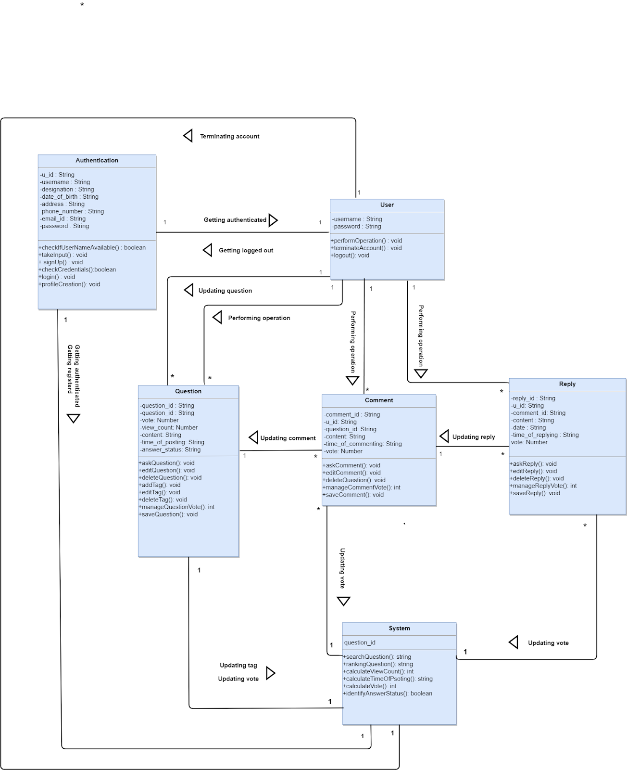

Figure 3: class diagram

**CHAPTER 7: FLOW-ORIENTED MODELING**

**7.1 Data flow diagram**

**7.1.1 Level 0 Data Flow Diagram**



**7.1.2 Level 1 Data Flow Diagram**



**7.1.3 Level 2 Data Flow Diagram**



# CHAPTER 8: BEHAVIORAL MODELING

The behavioral model indicates how software will respond to external events. Two different behavioral representations are discussed in this chapter. The first indicates how individual class changes state based on external events and the second shows the behavior of the software as a function of time.

## 8.1 Event Identification

|  |  |  |  |
| --- | --- | --- | --- |
| **SL No** | **Event** | **Initiator** | **Collaborator** |
| 1. | Sign Up option  selected | Authentication |  |
| 2. | Log in option selected | Authentication |  |
| 3. | Information for account is given | Authentication |  |
| 4. | Sending mail notification | Authentication | System |
| 5. | User name and password  given | Authentication |  |
| 6. | Username and password matched | Authentication |  |
| 7. | Username and password mismatched | Authentication |  |
| 8. | Username available | Authentication |  |
| 9. | Username not available | Authentication |  |
| 10.. | Logged in | Authentication | User |
| 11. | Logging out | User |  |
| 12. | Log out option selected | User |  |
| 13. | Perform operation selected | User | Question, Comment, Reply |
| 14. | Terminate account option selected | User |  |
| 15. | Account Terminated | User |  |
| 16. | vote given | User | System |
| 17. | vote received | System | User |
| 18. | Rating updated | System | Question |
| 19. | vote counted | System | Question, Comment, Reply |
| 20. | question added | Question |  |
| 21. | question edited | Question |  |
| 22. | question deleted | Question |  |
| 23. | tag updated | Question | System |
| 24. | question saved | Question | System |
| 25. | comment added | Comment |  |
| 26. | comment edited | Comment |  |
| 27. | comment deleted | Comment |  |
| 28. | comment saved | Comment |  |
| 29. | reply added | Reply |  |
| 30. | reply edited | Reply |  |
| 31. | reply deleted | Reply |  |
| 32. | reply saved | Reply |  |

## 8.2 State Transition

1. User:

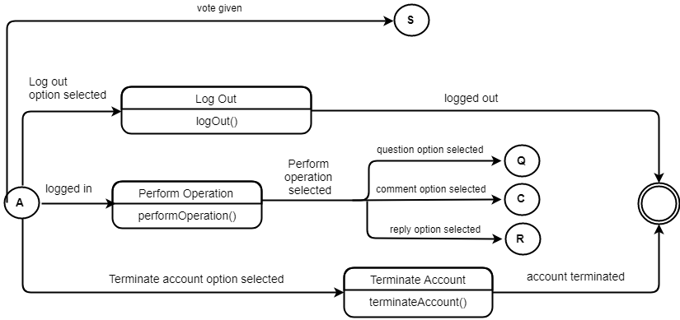

1. System

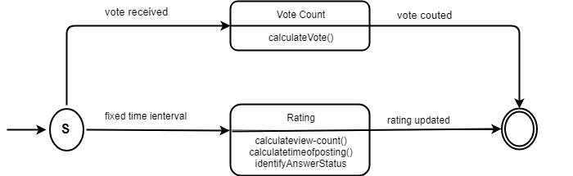

1. Reply

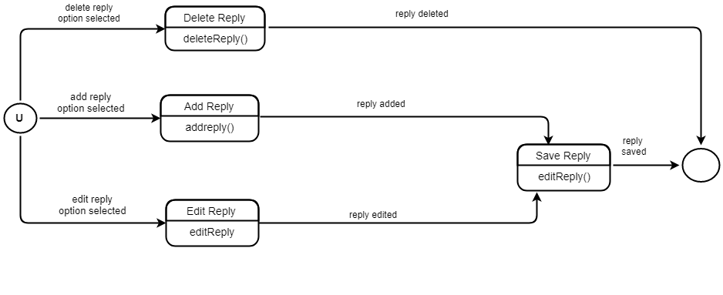

1. Question

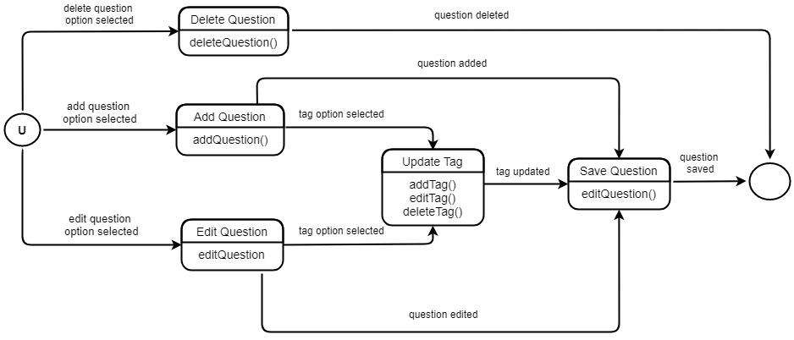

1. Authentication

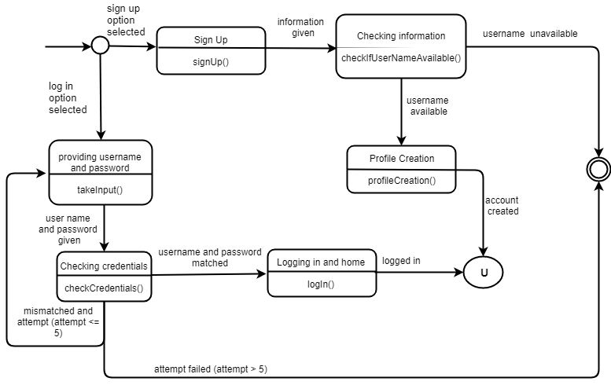

1. Comment

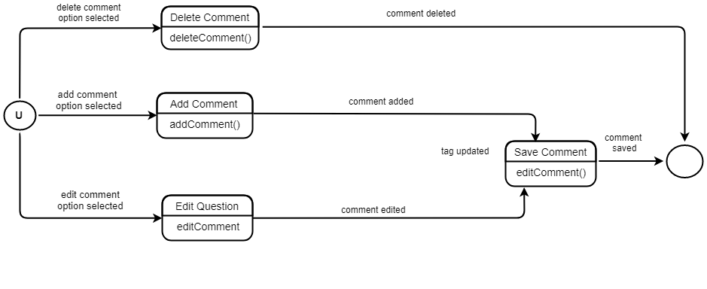

## 8.3 Sequence diagram

A sequence diagram is an interaction diagram that shows how objects operate with one another and in what order. It is a construct of a message sequence chart. A sequence diagram shows object interactions arranged in time sequence

